Kunsthalle Praha to open 22 February 2022
with inaugural exhibition Kinetismus: 100 Years of Electricity in Art

Press Release
21 January 2022

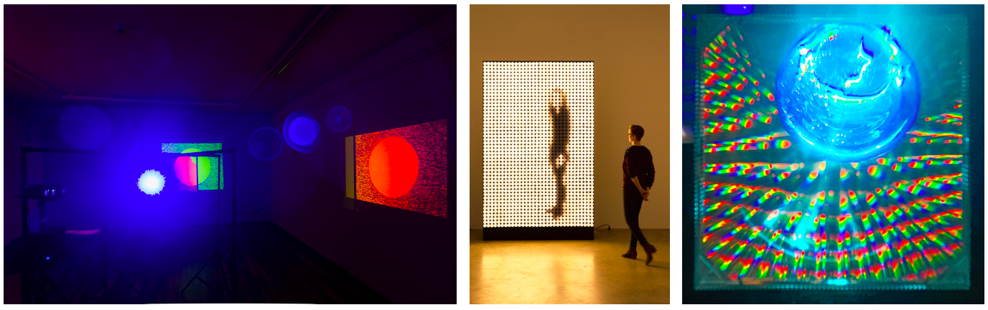
Image caption below

- Kunsthalle Praha (Prague, Czech Republic) will open to the public on 22 February 2022.
- The major new not-for-profit organization will be dedicated to bringing new perspectives on Czech and international art of the 20th and 21st centuries to a wide audience, and to creating an open, interdisciplinary space for the exchange of ideas and knowledge.
- Its inaugural exhibition titled Kinetismus: 100 Years of Electricity in Art, will be on view through 20 June 2022, and will explore how electricity has transformed artistic practice from the start of the 20th century to the present day.

Set to become a highlight of the city’s urban and cultural landscape, the major new not-for-profit, and non-governmental institution, established by the Pudil Family Foundation, will offer a dynamic programme of short-term exhibitions aiming to connect modern and contemporary Czech and international art and innovative educational activities. Designed by Czech architecture studio Schindler Seko, the space will span 5,700 sq. metres and include three large gallery spaces, a design shop, a bistro, and a café with a terrace that features views of Petřín Hill and Prague Castle.

OPENING PROGRAMME

Kinetismus: 100 Years of Electricity in Art

The opening exhibition will celebrate the original function of Kunsthalle Praha. Known as the Zenger Electrical Substation in the 1930s, the building housed large amounts of technology that generated electricity for the city. As technology evolved, the vast space was no longer needed, and it was converted into Kunsthalle Praha which still houses the substation’s equipment in a small area in its basement.

The exhibition is also a nod to Czech avant-garde artist and pioneer of kinetic art Zdeněk Pešánek who created a series of allegorical kinetic light sculptures titled 100 Years of Electricity for the façade of the Zenger substation in 1936. The artwork, which brought together art, science, and sound, was presented at the International Exposition of Arts and Technology in Paris in 1937 where it perfectly embodied the theme of the Exposition: Technology in Modern Life. Unfortunately, the piece mysteriously disappeared after it returned to Prague and was never installed on the façade it was originally created for. Failing to recover these lost sculptures - of which only the preparatory models remain - the Kunsthalle Praha team chose to focus on bringing Pešánek’s ideas back to life and exploring their legacy. The exhibition title also refers to his seminal book Kinetismus which discusses the possibilities offered by the integration of motorised movement and artificial light in art.

Kinetismus: 100 Years of Electricity in Art will explore how electricity has transformed artistic practice from the start of the 20th century to the present day and focus on four key areas - cinematography, kinetic art, cybernetic art, and computer art. The exhibition will feature over ninety works of art by several generations of artists from all around the world, including independent figures and members of emblematic groups such as Bauhaus, GRAV, Dvizhenie, ZERO, and teamLab. The show will include the work of pioneers such as Mary Ellen Bute, Zdeněk Pešánek, László Moholy-Nagy and Marcel Duchamp; established names such as Julio Le Parc, Yaacov Agam, Woody and Steina Vašulka, François Morellet, Adéla Matasová, William Kentridge; and representatives from younger generations such as Refik Anadol, Žilvinas Kempinas, Shilpa Gupta, Olafur Eliasson, Michael Bielický & Kamila B. Richter.

The exhibition has been conceived by guest curator Peter Weibel (theoretician, artist and director of the ZKM l Center for Art and Media in Karlsruhe, Germany), alongside co-curators Christelle Havranek (Chief Curator at Kunsthalle Praha) and Lívia Nolasco-Rózsás (scientific associate and curator) and has benefited from important loans from private lenders and major institutions including ZKM (Germany), Tate (UK) and Centre Pompidou (France).

Education

The exhibition will be accompanied by a comprehensive digital guide that visitors can connect to on their devices and through which they can choose from several options, including two thematic routes and an audio guide.

A richly illustrated catalogue published in conjunction with the exhibition features contributions by the curatorial team and many other relevant authors, and an illustrated timeline tracing the milestones of technological, theoretical, and artistic developments brought about by electricity from the 1920s to the present day.

The exhibition will feature interactive activities designed for visitors of all ages including a nine-metre Art Wall offering the unique experience of creating one’s own work. The Art Wall is dedicated to ‘light graffiti’, which thanks to an interactive console will allow drawing with light and creating large-format works. Moreover, children together with adults can enjoy the playful space of Kidshalle and unleash their creative potential.

Zenger Electrical Substation: Electricity in Architecture, Electricity in the City

In addition to the inaugural exhibition, Kunsthalle Praha will also pay tribute to the building’s rich industrial past in a second show titled Zenger Electrical Substation: Electricity in Architecture, Electricity in the City. The exhibition which has been curated by art and architecture historian Vendula Hnídková explores the role electricity and modern technology have played in the development of the building as well as Prague’s history more generally. Alongside learning about the history of the space, visitors will be given the opportunity to immerse themselves in a video-projection of artist Zdeněk Pešánek’s lumino-kinetic sculptures that he originally designed for the façade, and play with a large-scale construction set of the building.

Cabinet of Electrical Curiosities, Mark Dion

Kunsthalle Praha has also unveiled a site-specific installation titled Cabinet of Electrical Curiosities by conceptual artist Mark Dion. As an archaeologist of the present, the artist assembled the cabinet out of objects and artefacts collected on site during Kunsthalle Praha’s construction. The work will tell the story of the building itself, from its construction in the 1930s to its current conversion, and will remain on permanent display.

Ivana Goossen, Director of Kunsthalle Praha, said: ‘After more than six exciting and challenging years of planning, reconstruction and programme development, we are thrilled to finally open the doors of Kunsthalle Praha to the public. I am profoundly grateful to our team and to our partners - the curators, artists, institutions, and lenders of artworks who trusted us at the beginning when all we had was a ruin in the centre of Prague, some architectural drawings, a sparkle in our eyes, and lots of potential. Opening to the public with an ambitious international exhibition like Kinetismus would not have been possible without them.’

Christelle Havranek, Chief Curator of Kunsthalle Praha, said: ‘With our inaugural exhibitions, we introduce the philosophy and approaches that will inform Kunsthalle Praha’s programming. Thus we aim to reveal the identity of the new space that we are shaping: a place of encounter between past and present, here and elsewhere, and where knowledge meets creativity.’

For more information visit: http://www.kunsthallepraha.org/

- Ends -

Please click here to download hi-resolution images and portraits

Local press contact
Kunsthalle Praha | Ondřej Čížek | ocizek@kunsthallepraha.org | +420 605 921 770

International press contact
Sutton | Ella Roeg | ella@suttoncomms.com | +44 (0) 20 7183 3577

Facebook: Kunsthalle Praha
Instagram: kunsthallepraha
Twitter: @KunsthallePraha
Vimeo: Kunsthalle Praha
#KunsthallePraha

About Kunsthalle Praha

Kunsthalle Praha (Prague, Czech Republic) is an international and interdisciplinary platform for art and culture; an open meeting point where art lives and engages with a wide audience. Located in the former Zenger Electrical Substation in the historical centre of Prague, Kunsthalle Praha’s mission is to support artistic discovery and research, to connect the Czech and international art scenes and to bring the experience of art of the 20th and 21st century to the widest possible audience with a dynamic, contemporary programme. Directed by Ivana Goossen, the Kunsthalle occupies a total of 5,700 square meters, encapsulating 1,300 square metres of exhibition space. Its programme consists of temporary exhibitions, educational projects, workshops, and cultural events. Kunsthalle Praha was established as a not-for-profit and non-governmental institution by The Pudil Family Foundation.

About the Pudil Family Foundation

The Pudil Family Foundation was established in 2014 by Mr. Petr Pudil and Mrs. Pavlína Pudil. It is an open non-profit organisation dedicated to supporting innovative exhibitions, research projects and educational activities that promote the understanding and appreciation of Czech and international modern and contemporary art.

Image caption R-L: Woody Vašulka, Light Revisited, 1974-2001, spatial interpretation of Woody and Steina Vašulka’s collaborative video piece Noisefields, 1974, audio/video installation, dimensions variable, system of semi-permeable dichroic mirrors, steel construction, video projector, player, stereo sound, source tape: 3/4” U-matic, colour, sound, looped, 12:05 min, Vašulka Kitchen Brno (on permanent loan from BERG Contemporary, Reykjavík), photo: Matěj Strnad, © Vašulka Kitchen Brno, © courtesy of BERG Contemporary and the Vašulkas; Xavier Veilhan, Light Machine, 2015, electronic components, LEDs, metal, plastic material, 277.5 × 170.5 × 56 cm, Perrotin, Paris. Photo: Claire Dorn © Veilhan / ADAGP Paris, 2021, courtesy of the artist and Perrotin; Heinz Mack, Virtuelles Volumen I / Virtual Volume I, 1964, acrylic glass, aluminium, electrical accessories, 40.5 × 40.5 × 50 cm, courtesy of the artist, photo: © Studio Mack.

