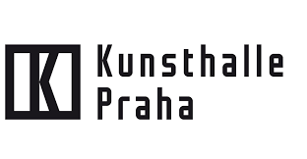

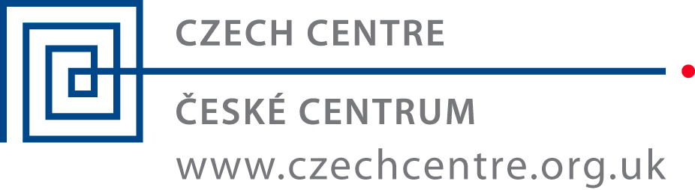
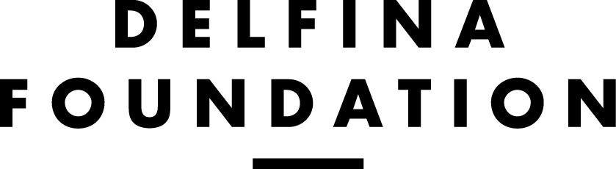

OPEN CALL FOR CZECH
ARTISTS AND CURATORS

Through an interrelated programme of residencies, exhibitions, and events, Delfina Foundation (DF) provides a platform for artists, curators and thinkers to experiment with bold ideas, explore connections, learn new skills, and build collaborations with colleagues, communities and institutions.

In collaboration with Kunsthalle Praha, The Arts and Theatre Institute, Czech Centre London, Delfina Foundation is offering three residency opportunities for two artists and one curator. Each residency will be approximately 6 weeks in duration, two in Winter 2019 (March to April) and one in Autumn 2019 (October to November).

The research conducted at DF may develop into larger projects at Kunsthalle Praha.

DF’s residency programme is structured around seasons, which are:

Thematic: concentrated on advancing specific initiatives related the following areas: The Politics of Food, Performance as Process, The Public Domain and Collecting as Practice. More information about our thematic residencies can be found here.
Open: dedicated to supporting independent projects without particular outcomes

In 2019, Delfina Foundation is launching a new theme that crosses art, science and technology. While we strongly encourage applications that engage in these areas, or other themes at Delfina Foundation, Czech artists and curators from any background can apply for these residences, regardless of their interest in science and technology.

In general, Delfina Foundation’s residencies provide selected artists with an opportunity to engage in and gain exposure to the UK’s art and cultural scene. A loosely structured series of events and activities will be developed to enable the selected artist to:

- Research and develop areas of interest;
- Develop skills via training and mentoring;
- Access information and resources through independent study, field trips and workshops; and
- Participate in both internal and external/public events.

THE SELECTED ARTIST/CURATOR WILL RECEIVE:
- A six-week residency in London, including one return, economy-class flight, and a living allowance for food/per diems and materials;
- A single bedroom at DF, which is a shared house with some shared facilities, such as the laundry room, kitchen, and dining room;
- Opportunities to engage in the art scene in UK through structured and independent time and activities;
- Access to a programme of planned group activities and visits to cultural organisations in the UK; and

REQUIREMENTS:
- A Czech citizen, currently living and working in the Czech Republic or an artist/curator based in the Czech Republic with a long-term residence permit
- Seeking an opportunity to develop his/her practice and the concepts of his/her artistic work or curatorial work;
- Able to explain how the experience of an international residency may benefit his/her career development and local networks; and
- Proficient in English.

Additionally, the selected artists and curator will need to obtain travel insurance to cover medical emergencies, theft and other accidents.

OVERVIEW OF THE APPLICATION PROCESS:
Artists and curators must submit a completed application form in English, a CV and images of their work. The selection process will include interviews with the shortlisted applicants. More information follows the application form below.

23 December 2018: Deadline for applications
Week of 14 January 2019: Skype interviews with shortlisted artists/curators (times TBC)

Starting dates:
1 x 6-week residency starts from 4 March 2019
1 x 6-week residency starts from 4 March 2019
1 x 6-week residency starts from 16 September 2019

ABOUT THE ART, SCIENCE & TECHNOLOGY THEME
In 2019, DF is launching a new thematic area to bring together shared interests and concerns in the fields of art, science and technology. This theme will initially underline some of DF’s activities from January 2019 and build towards a concentrated programme of events, projects and exhibitions in autumn 2019, interrelated with residencies. During this season, we are also welcoming writers, researchers, scientists, entrepreneurs and other practitioners who are interested in engaging with artists to develop new creative and critical approaches.

Through our programme, we will explore ideas that have the capacity to go beyond exhibition spaces, science labs and publications. DF is interested in different modes of production and dissemination, including those that interface with the coalface of environmental concerns to those that might have commercial viability.

The ambition is to create a focused environment to foster collaboration, incubate ideas and support the development of new projects that can make an impact on the world around us.

ABOUT DELFINA FOUNDATION (DF)
www.delfinafoundation.com
DF is more than London’s largest international residency programme – it is a home where the next generation of contemporary artists, curators and thinkers are supported and nurtured.

Based in two newly renovated Edwardian houses near Buckingham Palace, DF is an independent, non-profit organisation dedicated to fostering artistic talent and facilitating exchange through residencies and public programmes ranging from workshops to exhibitions, both in the UK and with international partners.

DF is the successor to Delfina Studio Trust. From 1988 to 2006, Delfina Studio held an unprecedented record for supporting artists through residencies and exhibitions, including more than a dozen Turner Prize nominees. DF is proud to build on this history.

DF’s work is followed by key arts professionals and our audiences include arts patrons, curators, major art collectors and the general public. Over the last year, DF’s work has been featured in the Financial Times, The Independent, New York Times, Art Review, Frieze, ArtAsiaPacific, Artforum and The Art Newspaper.

ABOUT KUNSTHALLE PRAHA
www.kunsthallepraha.org/

Kunsthalle Praha is a new space for art and culture being developed in a former industrial building located in Prague‘s historical centre. Kunsthalle Praha will offer visitors an extensive programme of exhibition, cultural events and social activities.

Kunsthalle Praha’s mission is to engage diverse audiences in a deeper understanding and appreciation of Czech and international art of the 20th and 21st centuries. The aim is to create a leading cultural institution grounded in expertise and open cooperation, a space which integrates the experience of art and culture into everyday life.

Kunsthalle Praha is a non-profit organization established by The Pudil Family Foundation.

ABOUT CZECH CENTRE LONDON
www.czechcentre.org.uk

The Czech Centre's mission is to actively promote the Czech Republic by showcasing Czech culture in the UK. Its programme covers visual and performing arts, film, literature, music, architecture, design and fashion. As well as hosting its own events, the Czech Centre offers support for other groups organising Czech related initiatives in the UK.

The centre also seeks to further enhance cultural relationships between the UK and the Czech Republic through curatorial visits, media tours and artistic residencies.

The Czech Centre London opened in 1993. It is a non-political organisation supported by the Czech Ministry of Foreign Affairs as part of a worldwide network of 21 Czech Centres operating in 19 countries and on three continents.

ABOUT ARTS AND THEATRE INSTITUTE - ARTISTS RESIDENCY PROGRAMME
https://www.idu.cz

Arts and Theatre Institute - Artists in Residence Programme offers and coordinates residencies for artists working in the arts. The programme has run since 2004 and it is designed to promote international collaboration and communication and most of all to provide artists with time and space to engage in creative work and pursue inspiration without interruption. It provides Czech artists with the opportunity to travel abroad, while on the Czech side the Arts Institute in Prague attends to visiting artists accepted into the programme, which includes providing them with local contacts. As an intermediary, the Arts Institute actively seeks partners at home and abroad through long-term contacts, holds competitions for arts residencies abroad, organises workshops for artists from abroad in the Czech Republic, and provides services to the Czech and foreign artists selected to participate in the programme.

Between 2004 and 2014 more than 200 creative residencies were organised in which 176 Czech and foreign artists took part.

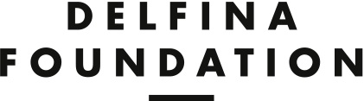

RESIDENCY APPLICATION FORM

Please do not alter this form in any way and complete each section in the relevant boxes adhering to the word count.

- ABOUT YOU

First name:
Last name:
Date of birth:
Place of birth:
Sex: (Male/Female/
They/etc.)
Nationality (as indicated in passport):
Current Address:
Telephone no:
Mobile no:
Skype ID:
Email address:
Website address:
Current employer:

- ABOUT YOUR WORK

- Please define your practice using five keywords:

1.
2.
3.
4.
5.

B. How would you describe your practice in 50 words?

C. Using your past, present or on-going projects as examples, please tell us more about your practice and interests. (maximum: 300 words, not exceeding the size of the box below)

3. YOUR MOTIVATION

A. Have you taken part in an international residency program before? If so, please provide brief details. (maximum: 50 words)

B. Why does this residency at Delfina Foundation interest you? Please tell us: (a) how this experience may benefit you and your practice at this stage of your career, (b) how you hope to use your time in London, and (c) how you hope to contribute to the residency. (maximum: 300 words, not exceeding the size of the box below)

C. Do you engage in science and technology in your practice or do you have a new project idea in these subject areas or other themes related to Delfina Foundation? Please note that it is not mandatory that you have an interest in art, science and technology but if you do, please use this space to elaborate. (max: 100 words)

D. Do you prefer a six-week residency in late winter or autumn 2019? Please tell us if you are available for the following dates. Delfina Foundation will make every attempt to match your availability.

1 x 6-week residency starts from 4 March 2019
1 x 6-week residency starts from 16 September 2019

4. References

Please list the contact details of one professional contact who can be a reference for you. We do not require a letter, but we may ask to speak to this person during the assessment of your application.

CONTACT
Name:
Title:
Address:
Telephone no:
Mobile no:
Email address:
Relationship to referee:

5. Additional materials

In one email, applicants are expected to submit:
- A completed version of this application form in PDF format. Please name your application, substituting your name below:
LastName_FirstName_Application.pdf
- A CV/resume. Please name your CV, substituting your name below:
LastName_FirstName_CV.pdf
- Portfolio (only one pdf file with all images and texts). Although there is no maximum number of images that will be accepted, we advise applicants to only submit relevant materials to reduce the size of email submissions. The images should include captions or short descriptions. For videos/films, please provide links to your own website, Vimeo page, YouTube page, etc. Do not attach actual video files. Please name your portfolio, substituting your name below:
LastName_FirstName_Portfolio.pdf
Please list relevant links below, particularly to videos, films or other documentation:
Description | Web address

Please submit only electronic copies of the three documents in ONE email under 5 MB to: opencall@delfinafoundation.com
In the subject line of your email, please write: Last Name_First Name_CZECH OPEN CALL
Important: Do not include any important information in the body of your email. Only information in your application form and the requested documents will be assessed. Also, do not submit more than the three required attachments.
Closing date for applications: 23rd December 2018

6. Confirmation

I confirm this information to be correct. I have completed the application form and submitted all additional required materials, by email only.

________________________ _________________________________

Place and date Type or input electronic signature

